**Project Design Phase-II Data Flow Diagram & User Stories**

|  |  |
| --- | --- |
| Date | 26 October 2022 |
| Team ID | PNT2022TMID51364 |
| Project Name | Car Resale Value Prediction |
| Maximum Marks | 4 Marks |

**Data Flow Diagrams:**

A Data Flow Diagram (DFD) is a traditional visual representation of the information flows within a system. A neat and clear DFD can depict the right amount of the system requirement graphically. It shows a clear representation of how it the application works

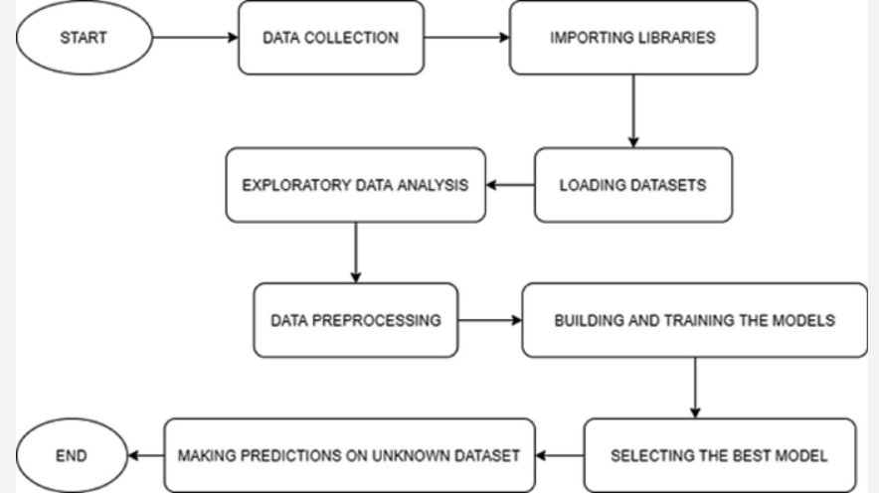

**User Stories**

Use the below template to list all the user stories for the product.

|  |  |  |  |  |  |  |
| --- | --- | --- | --- | --- | --- | --- |
| **User**  **Type** | **Functional**  **Requirement (Epic)** | **User**  **Story**  **Number** | **User Story / Task** | **Acceptance criteria** | **Priority** | **Release** |
| Customer (Mobile user) | Registration | USN-1 | As a user, I can register for the application using my email ID or mobile number, password, and  a confirmation password. | I can access my account / dashboard | High | Sprint-1 |
|  |  | USN-1 | As a user, I will receive confirmation email once I have registered for the application | I can receive confirmation email to confirm the given mail ID using an OTP/ an OTP to confirm the mobile number | High | Sprint-1 |
|  |  | USN-2 | As a user, I can register  for the application through Google | I can register & access the dashboard with Google Login | Low | Sprint-2 |
|  | Login | USN-3 | As a user, I can log into the application by  entering email & password |  | High | Sprint-1 |
|  | Dashboard | USN | As a user, I can enter the home page after I have logged in | I can enter/edit my personal details and my preferences | High | Sprint-1 |
|  | Car details | USN | As a user, I should enter the details of the car I wish to sell | I have to enter the year I purchased the car, pictures of the car, disclose any engine problem or any other problems with the working etc. | High | Sprint-1 |
| Customer Care  Executive | Queries and Helpline | USN1- | As a user, if I have any trouble with the application I can contact the customer care | I can contact customer care if I face any issues with the application, have any queries or facing any trouble with the buyer or seller I am dealing with. | Medium | Sprint-3 |
| Administra tor | Data gathering |  | As an admin, I should gather data on the  recent trends of the market | I can use this data to produce a more accurate prediction on the price of a car in the current market | High | Sprint-2 |
|  | Model Building |  | As an admin, I need to analyze and choose an algorithm that gives me the highest accuracy. I should train and test the dataset | I can try a few algorithms and check which gives me better accuracy | High | Sprint-3 |

|  |  |  |  |  |  |  |
| --- | --- | --- | --- | --- | --- | --- |
| **User**  **Type** | **Functional**  **Requirement (Epic)** | **User**  **Story**  **Number** | **User Story / Task** | **Acceptance criteria** | **Priority** | **Release** |
|  | Predict |  | As an admin, I need to predict the price of the used car. | I can predict the price with accuracy | High | Sprint-4 |
|  | Security |  | As an admin, I need to provide security for the user and for the data the user has shared | I can provide security for the data provided by the user by allowing only necessary people to be able to view it | High | Sprint-4 |